Lloyd Rainier P. Vitudio

Challenge #9

**HTML**

**Iframe**

<h1 class="intro">Movie Trailers</h1>

    <h2 class="intro">Percy Jackson and the Olympians: The Lightning Thief</h2>

    <iframe class="vid" src="videos/Percy Jackson and the Lightning Thief.mp4" name="iframe_1" title="Trailer_1"></iframe>

**Output**

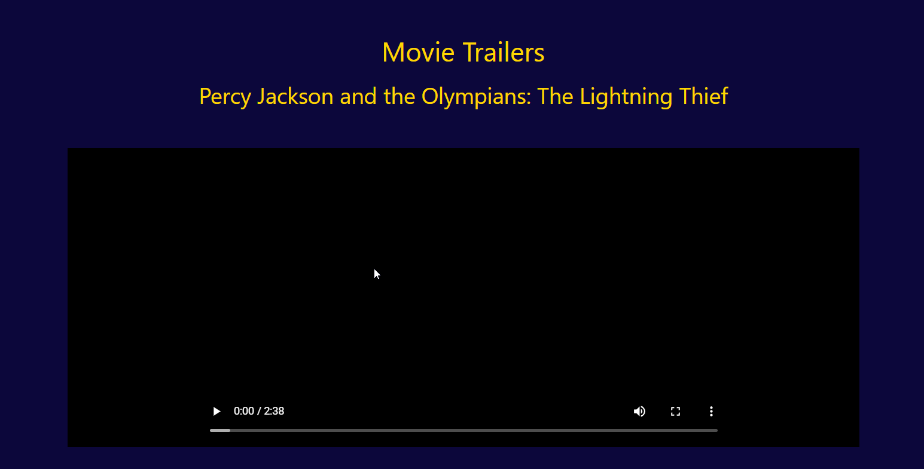

**Form**

<div class="content">

        <h1>Contact Us</h1>

        <p>If you have any questions or would like to get in touch, please email us at <strong>rainierpunzalan5276@gmail.com</strong>.</p>

        <p>Or contact us at <strong>09616316386</strong></p>

    </div>

    <form class="contact" action="#" method="post">

        <label for="name">Name:</label><br>

        <input type="text" id="name" name="name" required><br><br>

        <label for="email">Email:</label><br>

        <input type="email" id="email" name="email" required><br><br>

        <label for="message">Message:</label><br>

        <textarea id="message" name="message" rows="4" required></textarea><br><br>

        <input type="submit" value="Submit">

    </form>

**Output**

